Waters and Communities Award
TidyTowns Competition 2017

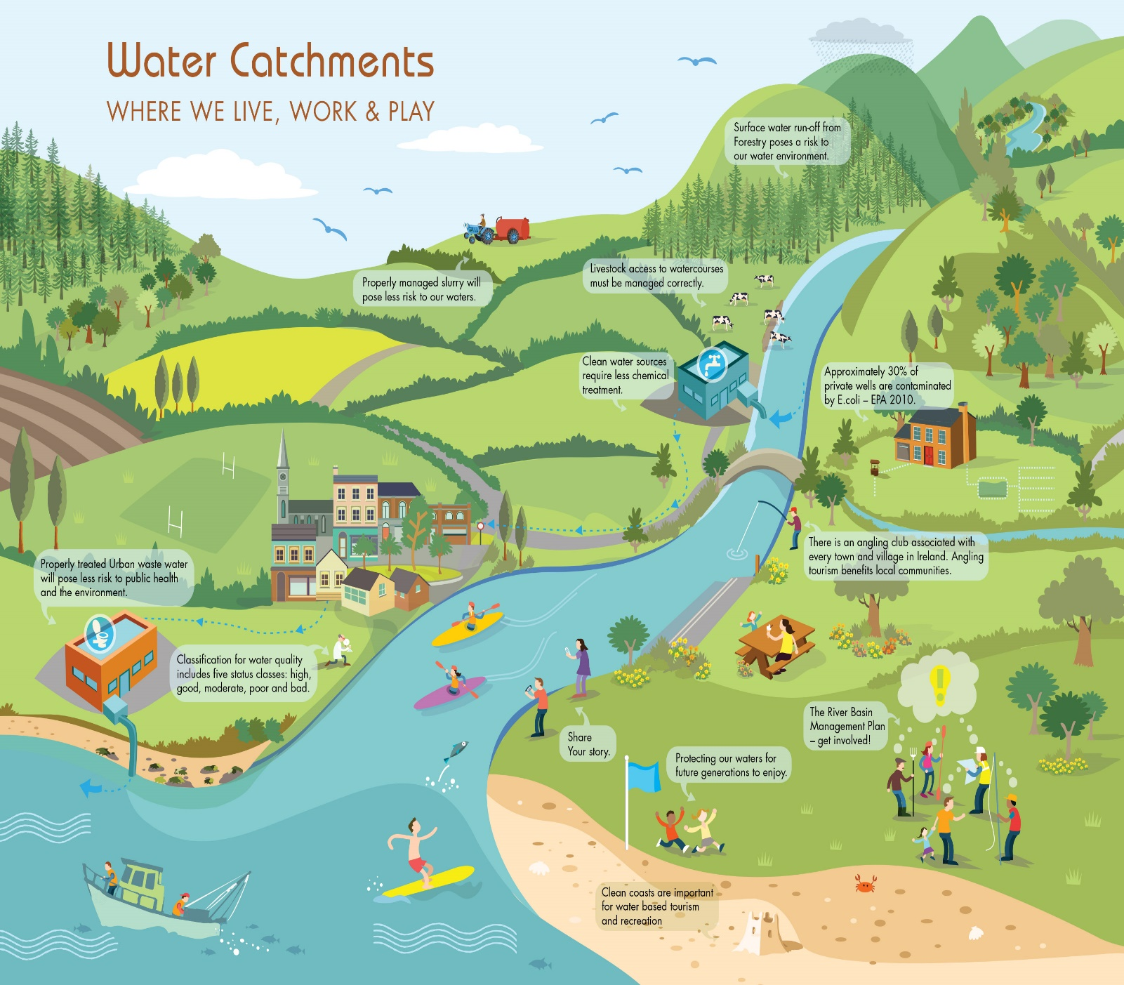

Community groups can play a vital role in the protection and improvement of our natural water environment. Together, we can protect our waters for future generations to enjoy.

Enter this new Waters and Communities Award category for 2017 and help make a difference.

This award is to recognise communities who are taking positive steps towards raising awareness
and showing appreciation of their local rivers, lakes, streams, canals, coast and ground water.

This competition is open to any community group

About the Waters and Communities Award

The Waters and Communities Award is a new category for 2017. The award is to recognise communities who are taking positive steps towards raising awareness and showing appreciation of their local rivers, lakes, streams, canals and coast. The Award is sponsored by Inland Fisheries Ireland www.fisheriesireland.ie (responsible for managing the inland fisheries and sea angling sectors); Waterways Ireland www.waterwaysireland.org (responsible for the management of inland navigable waterways) and the Local Authority Waters and Communities Office www.watersandcommunities.ie (working with communities to get involved in the management of natural waters).

Prize Fund for 2017
Four Regional Award Winners Four Regional Runner Up Award Winners
€1,000 each €500 each
There will also be an additional prize of €1,000 for the overall winner of the four regions

Application Form for the TidyTowns Waters and Communities Award 2017
(for projects completed during 2016 or ongoing in 2017)
Name of TidyTown or other community group Main contact person’s name

Email: Phone:

Postal Address:

- Please demonstrate how your community group has helped raised awareness of your local water body (eg. clean up, development of amenity area(s), biodiversity information such as signage, information leaflets, habitat surveys, bird boxes, outdoor classrooms, developing of safe access, control of invasive species, instream measures, promotion of angling etc).

- Please outline how your project involved the wider community? (eg. did you work with schools, landowners or other groups?).

- Did you engage with your Local Authority or Local Development Company or any public agencies in developing your project? If so, please provide details.

- Please outline the long term environmental benefits of your project to the local community.

- Additional information and plans for the future.

Photographs to accompany your application are welcome
Judging the Award

All entries will be assessed by a panel of judges appointed by Inland Fisheries Ireland, Waterways Ireland and the Local Authority Waters and Communities Office.

How to Apply: | Please reply by writing/typing in this document and returning it electronically or submitting by post
Email: tidytowns@ahg.gov.ie | Please insert ‘TidyTowns Waters and Community Awards’ in the subject line
By Post to: | TidyTowns Waters and Communities Award  TidyTowns Unit  Department of Arts, Heritage, Regional, Rural & Gaeltacht Affairs  Government Offices  Ballina  Co. Mayo  F26 E8N6

TidyTowns Competition Terms and Conditions apply as appropriate
Closing date: Thursday, 25th May 2017

Please stay safe while working close to water. For more details see http://www.iws.ie/

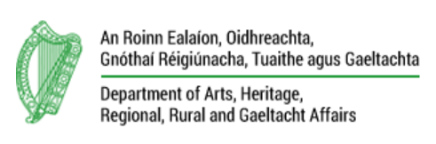 | 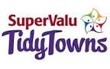 | 

